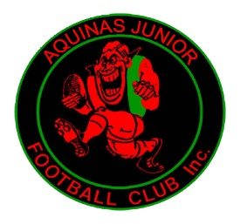 Coaching Application
Aquinas Junior Football Club
Great Ryrie Street Ringwood 3134 www.aquinas.com.au
Secretary: PO Box 886
Ringwood Vic 3134
Email: juniors @aquinas.com.au

Applicant Name
Address:
Telephone: |  | Mobile:
e-mail:
Position (s) Applied for:
Qualifications:

Experience:

Supporting Statement:

How will you retain and attract players to Aquinas?

How will you develop the team?

Describe your proposed game style.

Indicate your nominated support team (ie; Assistant, Runner, Trainer)

Do you have future aspirations at Aquinas beyond coaching

Level 1 Coaching Qualification and Working with Children Check:
League and Club Rules require coaches to have
• A Level 1 coaching qualification or in receipt of a Level 1 coaching qualification by
May 31 in the year that they are coaching (NB the Club will pay the fees for attending a
Level 1 course).
• A valid working with children check prior to the commencement of pre-season training
and for the duration of the season.

For queries please contact

Barry Jess (President)- 0418314849 or

Gavan Harkin (Vice President)- 0419 117652

Applicant’s Signature
__________________________
Date ___/____/__________

